**Design Document: NASA Psyche Mission Game**

**1. Project Overview**

* The NASA Psyche Mission Game is a web-based educational game designed to engage children and users of all ages by teaching them about NASA’s Psyche mission, planets, moons, and asteroids. The game will involve a trivia section to educate players about space, combined with an arcade-style mini-game where players land a spacecraft on a chosen planet or asteroid. The design will be cartoony and colorful to keep children engaged. The game aims to strike a balance between entertainment and learning.
* **Platform:** Web-based, accessible through desktop browsers.
* **Timeline:** Project completion date is set for December 7, 2024.

**2. User Experience (UX) Design**

* **Target Audience:**
  + Primary target: Children (younger age groups)
  + Secondary target: General public (all ages)
* **Core Game Flow:**
  + **Main Menu**:
    - Options: Play, Tutorial, Settings (for sound).
  + **Trivia Section**:
    - A question from a randomized trivia bank is displayed.
    - Players must select the planet, moon, or asteroid that fits the description.
    - Immediate feedback with points awarded for correct answers.
  + **Mini-game (Landing Section)**:
    - After choosing the correct celestial body, players enter the landing mini-game.
    - Using arrow keys, players navigate a shuttle to land on the planet’s surface.
    - Points awarded based on landing performance.
  + **Endgame/Scoring**:
    - Points are totaled and displayed after a complete game run.
  + **Tutorial Section**:
    - Step-by-step guide explaining the trivia, planet selection, and lander mini-game.

**3. Functional Requirements**

* **Main Menu:**
  + Buttons: Play, Tutorial, Settings.
  + **Settings:** Toggle sound effects (persistent across screens).
* **Trivia Section:**
  + Display a random trivia question about Psyche, planets, or other celestial bodies.
  + Select from a list of planets/moons/asteroids ordered from closest to the Sun.
  + Immediate feedback on correctness and points displayed.
* **Mini-game (Landing):**
  + Spacecraft lander mini-game.
  + Arrow key controls for movement.
  + Points for landing accuracy.
  + Simplified arcade physics to accommodate various age groups.
* **Scoring & Feedback:**
  + Points displayed at the top-right corner.
  + Messages for correct/incorrect answers in the trivia.
* **Non-Functional Requirements:**
  + **Latency**: 2-3 second delay after planet selection before starting the landing mini-game.
  + **Portability**: Accessible through desktop browsers.
  + **Reliability**: Game should restart from the beginning in case of a crash.
  + **Usability**: Easy-to-follow tutorial with an intuitive interface for young users.

**4. Game Mechanics**

* **Trivia Section**:
  + Randomized trivia questions focused on Psyche and celestial bodies.
  + The trivia difficulty could increase based on user performance (optional).
* **Mini-game (Landing)**:
  + Players must land a spacecraft on the planet or asteroid surface they selected during the trivia.
  + Basic arcade-style movement, physics simplified for fun gameplay.
  + Terrain and landing platforms change based on the planet/asteroid.

**5. Visual Design**

* **Art Style**:
  + Cartoony and colorful to appeal to children.
  + Simple yet engaging planet and asteroid visuals.
* **User Interface (UI)**:
  + Clear buttons for Play, Tutorial, and Settings.
  + Simple trivia questions interface with easy-to-click planets/asteroids.
* **Mini-game Interface**:
  + Shuttle displayed on the screen with terrain at the bottom.
  + Visual feedback for successful or failed landings.

**6. Audio Design**

* **Sound Effects**:
  + Simple space-themed sound effects.
* **Music**:
  + Background music that is light and fun but not too distracting.

**7. Technical Constraints**

* **Platform**: Web-based game accessible via desktop browsers.
* **Game Engine**: Godot.
* **Hosting**: Game will likely be hosted on NASA’s servers or an appropriate hosting solution.
* **Development Tools**: Standard development environments for Godot, with code written in GDScript (Godot).

**8. Assumptions**

* The trivia content will focus on Psyche but may include general space facts.
* The game is designed primarily for young children but must be enjoyable for all age groups.
* The mini-game’s physics will be arcade-like, simplifying the gameplay for younger audiences.
* NASA will provide hosting for the game if necessary.

**9. Dependencies**

* Availability of appropriate sound effects and visual assets for the game's cartoony design.
* Access to NASA’s Psyche mission data and trivia content.
* Learning curve for the team to master Godot within the project's timeline.
* Reliable internet access to ensure the game works on web browsers.

**10. Acceptance Criteria**

* **Gameplay:**
  + The game progresses through the trivia and landing mini-game without crashes or critical bugs.
  + Players can select answers, receive feedback, and see their score at the end.
  + The landing mini-game works as intended, allowing players to land a spacecraft.
* **User Experience:**
  + The game’s UI is intuitive, and players can easily navigate the tutorial and gameplay.
  + The sound settings work consistently across all screens.
* **Visuals & Audio:**
  + The game’s visuals are colorful, engaging, and consistent with the cartoony style.
  + Sound effects and music fit the game’s theme and audience.
* **Educational Value:**
  + Trivia questions accurately reflect information about the Psyche mission and other space topics.
  + Players gain knowledge of space through trivia and gameplay without losing engagement.

**Wireframes**

Start Page

-Credits so people can see disclaimer, and names of participants. Slack->psyche capstone info

-participant info->publishing guidelines folder

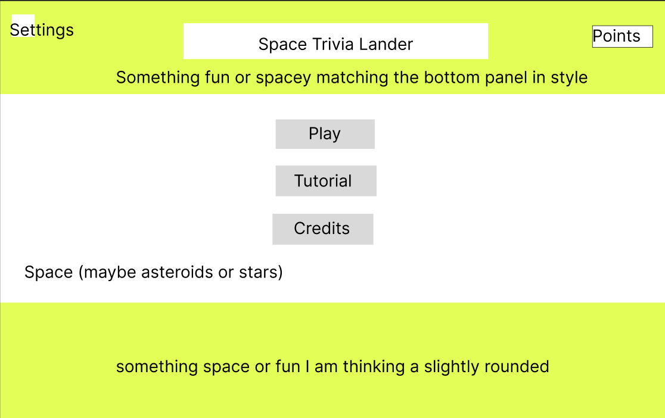

Trivia Page

-Make sure all trivia is separate from the actual Psyche mission. Make sure people know that this isn’t the official psyche mission.

- Trivia will be factual not necessarily close to the planets\

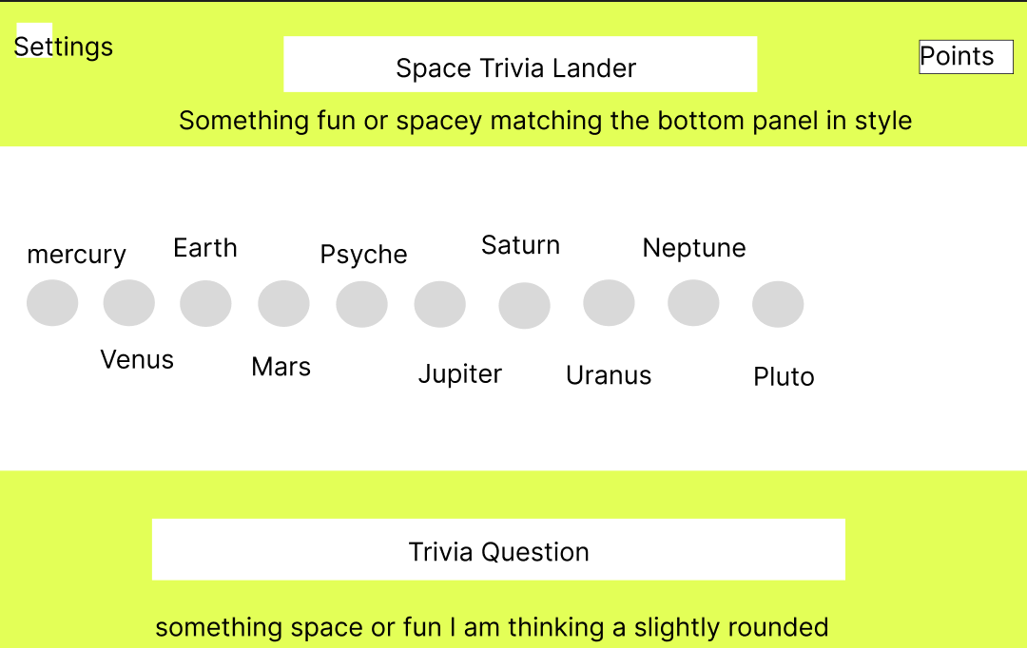

Trivia Answer Page

Lander Page

Trivia Tutorial Page

Trivia Answer Tutorial Page

Lander Tutorial Page

**Project Timeline for Psyche Web-Based Game**

**Completion Date: December 7, 2024**  
**Team Members: 5-6 People**

**Week 1: October 14 - October 20**

* **Task**: Project Planning & Setup
  + Finalize the requirements document, design the game flow, and clarify educational and entertainment goals.
  + Assign roles: decide who will work on the trivia questions, gameplay mechanics, landing mini-game, UI design, and sound effects.
  + Set up development tools and choose the game engine (Unity or Godot).
  + Initial brainstorming session on trivia questions, visual style, and basic mechanics.

**Week 2: October 21 - October 27**

* **Task**: Game Design & Basic Prototyping
  + **Trivia Section**: Start implementing a simple interface for the trivia questions. Begin working on the trivia bank (at least 10-15 questions focused on space and Psyche).
  + **Landing Mini-Game**: Prototype basic movement for the space shuttle landing mini-game with placeholder graphics.
  + **UI Design**: Begin designing the main game screen, including the "Play," "Tutorial," and "Settings" buttons.
  + **Milestone**: A rough playable version of the trivia interface and shuttle controls should be functioning by the end of the week.
  + **Meet with Customer**: Biweekly meeting with customer.

**Week 3: October 28 - November 3**

* **Task**: Core Development (Part 1)
  + **Trivia Section**: Complete trivia question mechanics (displaying questions, getting user input, showing correct/incorrect feedback).
  + **Landing Mini-Game**: Develop terrain and simple landing mechanics for at least one planet/asteroid.
  + **Art & Graphics**: Create basic placeholders for planets, moons, asteroids, and the shuttle.
  + **Sound Effects**: Begin sourcing or creating sound effects for feedback and landing.
  + **Milestone**: Trivia mechanics working with real questions, basic shuttle lander controls in place, placeholder graphics.

**Week 4: November 4 - November 10**

* **Task**: Core Development (Part 2)
  + **Trivia Bank**: Expand the trivia question bank (aim for at least 30 questions covering a variety of space topics).
  + **Landing Mini-Game**: Add more planets/asteroids with distinct terrains.
  + **Game Flow**: Integrate trivia selection with the transition to the landing mini-game.
  + **Settings and Tutorial**: Implement the settings button and the basic tutorial.
  + **Milestone**: Full gameplay loop should be functional—answering trivia, selecting a planet, and playing the landing mini-game.
  + **Meet with Customer**: Biweekly meeting with customer.

**Week 5: November 11 - November 17**

* **Task**: Game Polishing & Expanded Features
  + **Graphics**: Refine the visuals (cartoonish style, colorful planets, and simple yet appealing shuttle).
  + **Difficulty Levels**: If time allows, begin adding difficulty variations for different planets (e.g., different gravity, terrains).
  + **Tutorial & Sound**: Finalize the tutorial and add sound effects where appropriate.
  + **Scoring System**: Implement the points system for trivia and the landing game, ensuring it updates and displays correctly.
  + **Milestone**: All core features should be implemented, and the game should be playable from start to finish with basic sound and visuals.

**Week 6: November 18 - November 24**

* **Task**: Bug Fixing & Optimization
  + **Testing**: Begin testing the game for bugs and gameplay issues. Test across different browsers to ensure compatibility.
  + **Bug Fixes**: Fix any gameplay bugs, latency issues, or graphical glitches.
  + **Optimization**: Make sure that the game loads quickly, runs smoothly, and handles transitions well.
  + **Milestone**: The game should be fully functional, with no major bugs by the end of this week.
  + **Meet with Customer**: Biweekly meeting with customer.

**Week 7: November 25 - December 1**

* **Task**: Playtesting & Feedback
  + **Internal Playtesting**: Run a round of playtesting among team members. Focus on usability, fun factor, and educational impact.
  + **Refine Difficulty and Balance**: Tweak difficulty levels in both the trivia and mini-game sections based on playtester feedback.
  + **Customer Feedback**: Share the game with any potential stakeholders (teachers, parents, classmates) to gather final feedback.
  + **Milestone**: Refined game with feedback implemented.

**Week 8: December 2 - December 6**

* **Task**: Final Polishing & Presentation Preparation
  + **Final Polish**: Add final touches to sound effects, graphics, and any minor features (animations, effects, etc.).
  + **Final Testing**: Conduct a final round of testing to ensure there are no remaining bugs or performance issues.
  + **Documentation**: Write up any necessary documentation for submitting the project (user instructions, brief explanation of the game).
  + **Presentation Prep**: Prepare for any presentation or demonstration required for submission.
  + **Meet with Customer**: Biweekly meeting with customer.

**December 7: Final Submission**

* **Task**: Submit the completed game before the deadline, ensuring that all deliverables are ready.